

**Asset Practice Answers: Mathematics**

1. There are some plants planted in a circle in Ila's garden. Each plant has some flowers on it. For example Plant 1 has 2 flowers on it.

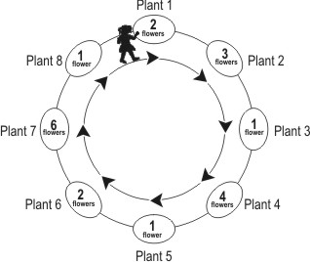

Ila starts from plant 1 and goes around the circle in the direction shown by the arrows. As she goes along, she keeps plucking all the flowers from the plants. After plucking flowers from which plant, will she have 11 flowers?

A. Plant 4

**B. Plant 5**

C. Plant 6

D. Plant 7

2. Arti, Deepa and Garima were given sheets having some small dots and some big dots. They had to draw a shape using 4 of those dots. For each small dot in their shape, they would get 1 point and for each big dot in their shape, they would get 10 points. For example, for the shape shown here the total points will be 10+1+1+1=13, because there is 1 big dot and 3 small dots.

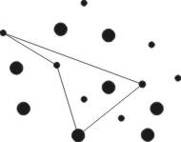

If Garima draws a shape using 4 of the dots, what is the highest score she can get?

A. 4

B. 10

**C. 40**

D. 44

3. Tia had 20 marbles. She distributed her 20 marbles between Mita and Zarina so that each of them got

10 marbles.

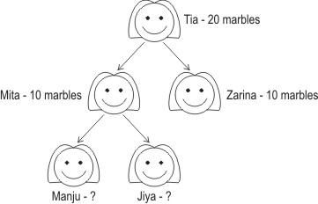

Mita also distributes her 10 marbles in the same way between Manju and Jiya. How many marbles would Manju get?

A. 20

B. 15

**C. 5**

D. 0

4. A shop sells eggs in four types of boxes - boxes containing 6, 12, 15 and 18 eggs (as shown in the figure).

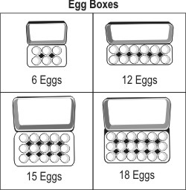

Khushi buys 2 boxes of '15 eggs' and Diana buys 5 boxes of '6 eggs'. Who has more eggs?

A. Khushi

B. Diana

**C. Both of them have the same number of eggs.**

D. (We cannot say because the type of boxes are different.)

5. Lily and her friends go to an amusement park. They find this chart pasted at the counter. It tells them how much they have to pay for different rides.

|  |  |
| --- | --- |
| Ride | Amount for one person |
| Merry-Go-Round | Rs 15 |
| Toy rain | Rs 10 |
| Jumping Jack | Rs 20 |
| Chiti Chiti Bang | Rs 10 |

Lily, Gargi and Gomti want to enjoy a ride on the 'Jumping Jack'. What is the total amount they have to pay?

A. Rs 20

B. Rs 30

C. Rs 45

**D. Rs 60**

6. The dots in the boxes form a pattern.

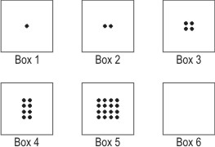

How many dots will be there in Box 6?

**A. 32**

B. 24

C. 20

D. 16

7. Devi, Puja and Priyam are running in a park. They start from the same place. But they take different paths to reach the ice-cream stall at the opposite corner.

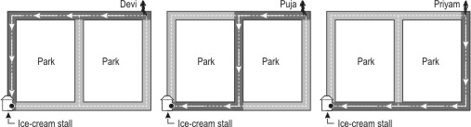

Who takes the LONGEST path? A. Devi

B. Puja

C. Priyam

**D. All their paths are equally long.**

8. Naimish has put some coins in rows. He has arranged 8 coins in each row. He has covered some of the coins with a paper as shown. How many coins are there totally?



A. 8

B. 12

C. 23

**D. 32**

9. Vinod had 85 marbles in a jar. He had another jar which was empty.

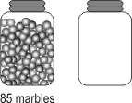

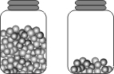He took 15 marbles from the jar and put them into the empty jar.

How many marbles does he have totally , in both the jars?

A. 70

**B. 85**

C. 100

D. (We can say only after counting.)

10. Look at the numbers shown below.

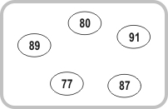

Which of these can be said about the given numbers?

A. They are all greater than 79.

B. They are all less than 90.

C. They are all between 70 and 90.

**D. They are all between 75 and 95.**

11. Which group below has more girls than boys?

A.  B. 

C.  **D. **

12. Which of these will be equal to 97?

**A. 7 ones + 9 tens**

B. 7 tens + 9 ones

C. 9 tens + 7

D. 9 ones + 7 ones



**Maths**

1. B: After plucking the flowers from plant 1, Ila will have 2 flowers. After plucking the flowers from plant 2, she will have

2 +3 = 5 flowers. After plucking the flowers from plant 3 she will have 5 + 1 = 6 flowers. Similarly after plucking the flowers from plant 4 she will have 6 + 4 = 10 flowers, and after plucking the flowers from plant 5, she will have

10 + 1 = 11 flowers.

2. C: Garima draws a shape using 4 dots. A small dot gives 1 point and a big dot gives 10 points. So the more the big dots you use, the more the points you get. To get the highest score possible, Garima should use all 4 big dots is it not? How many points does she get if she uses 4 big dots? 4 x 10 = 40. points. Can she get more points than this? No, because she can use only 4 dots and we have calculated the points for all 4 of them.

3. C: Mita has 10 marbles. If you divide 10 marbles equally between 2 of your friends, how many would each get? 5 marbles, right?

4. C: Khushi buys 2 boxes of 15 eggs. So she bought 2 x 15 = 30 eggs in all. Diana bought 5 boxes of 6 eggs. That is she bought 5 x 6 = 30 eggs in all. So both of them bought the same number of eggs. We cannot say that Khushi bought more eggs just because each of her boxes contain a greater number of eggs. We need to understand that though the number of boxes were different, the total number of eggs each one bought turned out to be the same.

5. D: According to the chart, the amount that one person has to pay to take a ride on the Jumping Jack is Rs 20. Lily, Gargi and Gomti, 3 girls want to take a ride on the Jumping Jack. So they have to pay Rs 20 each, that is 20 x 3 = Rs 60. Only one person can take the ride for Rs 20.

6. A: Look at the pattern carefully. There is one dot in Box 1, 2 dots in Box 2, 4 dots in Box 3, 8 dots in Box 4, 16 dots in Box 5 ... Did you get the pattern? Can you see that the number of dots are doubling from one box to the next? There are16 dots in Box 5. So there will be twice as many dots in Box 6, that is 2 x 16 = 32 dots.

7. D: The three girls start from one corner of the rectangular park and the ice-cream stall is at the opposite corner. So to get to the opposite corner, Devi first walks along the length of the park and then the breadth. Priyam first walks along the breadth and then the length. So aren't Devi and Priyam walking the same distance? Look carefully at Puja's path. Isn't the total distance that she covers also equal to the length of the park + the breadth of the park? Just because she takes two turns, does it become longer? No! So the paths of Devi, Puja and Priyam are equally long.

8. D: Naimish has arranged 8 coins in each row. There are 4 such rows. So there are 8 x 4 = 32 coins in all. Did you count 23 coins? Did you count the coins that Naimish has covered with the paper? No you didn't! Actually you don't need to count the coins one by one. Knowing that there are 4 rows with 8 coins each is enough to find the total number of coins.

9. B: When one of the jar is empty, there are 85 marbles in all in the two jars. When 15 marbles are put into empty jar, the marbles in the jar would reduce to 85 - 15, which is 70 marbles. So the number of marbles in the two jars = 70 + 15 = 85. Hence B is the answer. The question asks for total number of marbles in both the jars which is 85 and not 70. Hence A is incorrect.

10. D: 77 is a number less than 79. So A is not true. 91 is greater than 90. So B and C cannot be true. It can be seen that all the 5 numbers 80, 91, 87, 77 and 89 are less than 95 and greater than 75. Hence D is the answer.

11. D: In the figure in A, there are 9 boys and 8 girls. Boys are more than girls. In the figure in B, there are 6 boys and 6 girls. In the figure in C, there are 8 boys and 5 girls. There are 3 more boys than girls.

In the figure in D, there are 5 boys and 7 girls. There are 2 more girls than boys . So D is the answer.

12. A: 7 ones = 7 and 9 tens = 90. So 7 ones + 9 tens = 7 + 90, which is 97.

9 tens + 7 tens = 90 + 70 = 160 and not 97. Hence A is the answer and not C.